**Report: Covid-19 Vaccine Sentiment Analysis**

*By Arya Gowda*

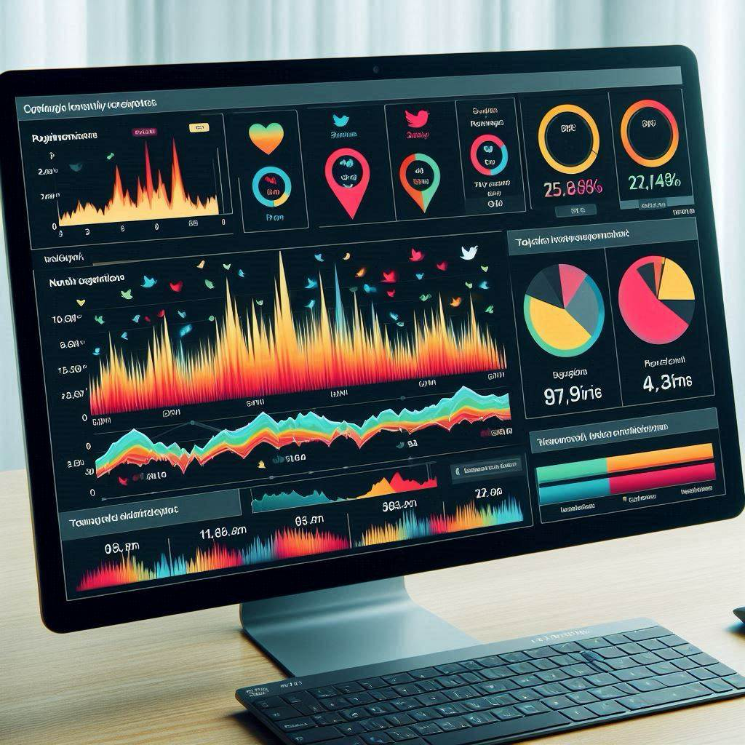

**Introduction**

In this report, we present a comprehensive analysis of sentiments expressed on Twitter regarding Covid-19 vaccines. The analysis aims to understand public perceptions and attitudes towards various vaccines, identify key trends, and extract actionable insights to inform public health communication strategies.

**Data Collection and Preprocessing**

* **Data Source**: We collected tweets related to Covid-19 vaccination using Twitter's API.
* **Preprocessing**: The raw tweet data underwent preprocessing steps, including removing Twitter handles, hashtags, URLs, special characters, and single characters, to clean the text for analysis.

**Sentiment Analysis**

* **VADER Sentiment Analysis**: We utilized the VADER (Valence Aware Dictionary and sEntiment Reasoner) tool for sentiment analysis, which is specifically designed for social media text.
* **Sentiment Metrics**: We calculated positive, neutral, and negative sentiments for each tweet.

**Exploratory Data Analysis (EDA)**

* **Sentiment Distribution**: Visualizations such as kernel density plots and cumulative distribution functions (CDFs) were used to explore the distribution of sentiments across tweets.
* **Temporal Analysis**: We analyzed sentiment trends over time, by month, and by season, to identify any patterns or fluctuations.

**Key Insights**

1. **Temporal Trends**: Sentiments fluctuated over time, with peaks and troughs corresponding to significant events such as vaccine announcements, regulatory decisions, and public debates.

1. **Seasonal Variations**: Sentiments varied across seasons, with potential correlations to changes in Covid-19 infection rates, vaccination drives, or media coverage.

1. **Keyword Analysis**: Sentiments differed based on keywords such as vaccine names (e.g., Pfizer, Moderna), Covid-related terms, and pharmaceutical companies (e.g., AstraZeneca), indicating varying perceptions and discussions around different aspects of vaccination.

**Advanced Analyses**

* **Time Series Decomposition**: Decomposing sentiment time series into trend, seasonal, and residual components provided deeper insights into underlying patterns and anomalies.
* **Word Cloud Analysis**: Word clouds visualized the most common words associated with both positive and negative sentiments, highlighting prevalent themes and topics.

**Conclusion**

The sentiment analysis of Covid-19 vaccine-related tweets revealed a dynamic landscape of public opinions and attitudes. By understanding these sentiments and the factors influencing them, public health authorities can tailor communication strategies, address concerns, and promote vaccine acceptance effectively.

**Recommendations**

1. **Targeted Messaging**: Craft targeted messaging campaigns addressing specific concerns and misconceptions identified through sentiment analysis.
2. **Engagement Strategies**: Engage with online communities and influencers to disseminate accurate information and counter misinformation effectively.
3. **Real-time Monitoring**: Continuously monitor sentiment trends and adjust communication strategies in response to evolving public perceptions and sentiments.

**Limitations and Future Directions**

* **Data Bias**: Twitter data may not represent the entire population and could be subject to biases.
* **Language Processing**: Further refinement of natural language processing techniques could improve sentiment analysis accuracy.
* **Longitudinal Analysis**: Conducting longitudinal studies to track sentiment trends over extended periods could provide deeper insights into evolving attitudes and behaviors.